Instructions for Preparing Manuscripts for the Journal of Innovations in Social and Applied Sciences
First Author¹, Second Author¹ and Third Author²
¹ Your Department Name, Complete University Name, City, Country
² Your Department Name, Complete University Name, City, Country
first.author@ jisas.com ✉; second.author@jisas.com; third.author@ jisas.com
Abstract  This document serves as an official LaTeX template for preparing manuscripts to be submitted to the Journal of Innovations in Social and Applied Sciences (JISAS). It provides authors with a standardized format designed to ensure uniformity, clarity, and professional presentation across all published papers. The template illustrates the correct structure of a manuscript, including section organization, citation format, figure and table placement, and reference styling according to the journal’s guidelines. It also demonstrates the use of appropriate font styles, margins, and spacing to maintain consistency throughout the document. Authors are encouraged to use this file as the foundation for their submissions by replacing the sample content with their own research text. Proper use of this template will help streamline the editorial and production process, minimize formatting revisions, and maintain the visual identity of JISAS as an open-access scientific journal committed to quality and accessibility. | Article History  Manuscript Received  Month xx, YYYY  First Revision  Month xx, YYYY  Final Acceptance Month xx, YYYY

Keywords: keyword one; keyword two; keyword three; keyword four; keyword five

Introduction
The introduction should begin by presenting the domain or research area and explaining its relevance. Provide sufficient background so that readers understand the broader context, current trends, and importance of the topic. Highlight why this domain has gained attention in recent years and what makes it valuable to investigate.
After introducing the domain, clearly describe the specific issue, gap, or limitation that exists within current research or practice. Explain why this problem is significant and how it impacts the field. Then briefly state how this paper addresses the problem and what approach or methodology has been adopted to propose a solution.
The objectives of this research are as follows:
• To identify the challenges or gaps within the selected domain
• To develop or propose an approach that addresses the identified problem
• To evaluate the effectiveness of the proposed solution using appropriate methods or experiments
The introduction section should conclude by outlining how the paper is organized. Briefly describe what each subsequent section covers so readers know what to expect in the rest of the manuscript.

Literature Review
The literature review should provide a clear and structured overview of existing research related to the study. Begin by summarizing key theories, models, concepts, or frameworks in the domain and explain how they relate to the topic. Present what has already been done in the field, allowing readers to understand the current state of knowledge.
Next, critically analyze prior studies instead of merely describing them. Highlight the strengths and contributions of previous work, but also point out limitations, inconsistencies, or areas that have not been explored. Explain where gaps exist in the literature and how these gaps have led to the need for further investigation.
The literature review should conclude by linking the identified gaps to the current research. Clearly show how the present study builds upon or differs from earlier work, establishing the contribution and justification for this research.
Recent studies have demonstrated significant advancements in predictive modeling and deep learning applications. Smith and Kumar highlighted the effectiveness of machine learning algorithms in improving prediction accuracy when dealing with diverse datasets [1]. Chen et al. proposed an improved deep learning model capable of real-time image classification and demonstrated superior performance over traditional approaches [2]. Williams presented a systematic review focusing on the adoption of adaptive learning technologies in higher education and concluded that intelligent systems can improve learning outcomes [3]. Similarly, Nguyen and Lee introduced performance evaluation metrics for predictive systems and emphasized their importance in assessing model efficiency [4]. In addition, Patel discussed foundational research methodologies that guide empirical studies and experimentation [5]. Oliveira and Costa further explored data preprocessing techniques and proved that optimized preprocessing significantly enhances model performance [6]. Furthermore, recent initiatives by the World Health Organization emphasize the growing role of digital innovation and data analytics in large-scale public health decision-making [7].

Methodology
The methodology section should explain the process adopted to conduct the research, ensuring that the study can be replicated by other researchers. This section presents the data, tools, procedures, and methods used to achieve the research objectives.

Dataset
Describe the dataset or data source used in the study. Include information such as size, origin, period of data collection, and key characteristics. If primary data was collected, explain the sampling method, instruments used (surveys, interviews, sensors, etc.), and participant details when applicable. If secondary data was used, mention the database or repository from which the data was obtained.

Proposed Methods
Explain the proposed method or model introduced in the study. Describe each component or step involved in the solution design, preferably supported by a diagram or flow representation. Clearly show how the proposed approach addresses the problem identified in the introduction and contributes to filling the research gap highlighted in the literature review. Figure 1 shows the workflow of the proposed method.

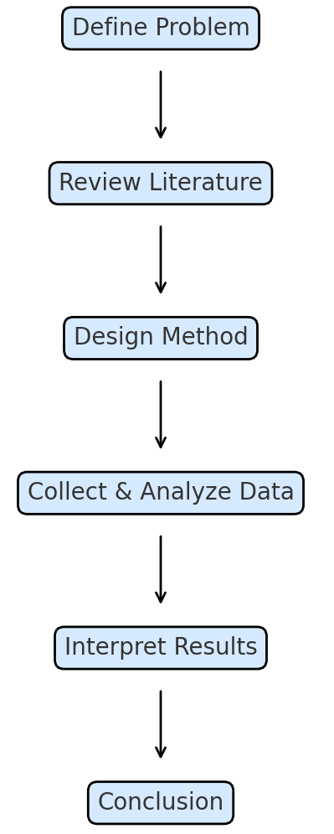
Figure 1: The workflow of the proposed method

Experimental Results
This section presents the results obtained from the experiments conducted on the dataset. The performance of the proposed method is evaluated and compared with baseline approaches to determine its effectiveness. All experiments were carried out under consistent conditions, and the same evaluation metrics were used throughout to ensure fairness and comparability.

Evaluation Metrics
For performance assessment, standard evaluation metrics were used to measure accuracy and reliability of the results. Metrics such as accuracy, precision, recall, and F1-score were calculated to understand how well the model performed. These metrics enable a balanced comparison between different models used in the experiment. The evaluation metrics: Accuracy, Precision, Recall, and F1-Score were evaluated as follows:
$$Accuracy =\frac{\left(TP + TN\right)}{\left(TP + TN + FP + FN\right)}$$
$$Precision = \frac{TP}{\left(TP + FP\right)}$$
$$Recall = \frac{TP}{\left(TP + FN\right)}$$
$$F1 = 2 ×\frac{\left(Precision × Recall\right)}{\left(Precision + Recall\right)}$$

Result Analysis
The results demonstrate that the proposed approach performs better than baseline methods across all evaluation metrics. The model achieved higher accuracy and produced fewer false predictions than the traditional approach. The improved performance confirms that the proposed method effectively addresses the problem identified earlier in the study. The interpretation of results also shows that incorporating additional parameters improved stability during testing.

Comparison With Existing Methods
Results were compared with other existing methods reported in previous studies. The comparative analysis indicates that the proposed model outperforms traditional techniques in terms of consistency and accuracy. While some existing methods performed reasonably well, they showed higher variability in results. The proposed method demonstrates strong and stable performance, indicating its usefulness and potential applicability to other datasets or domains. As shown in Table 1, the proposed model achieved the highest performance across all four evaluation metrics.

Table 1. Comparison of model performance using evaluation metrics
Model | Accuracy (%) | Precision (%) | Recall (%) | F1-Score (%)
Proposed Model | 94.8 | 93.6 | 95.1 | 94.3
Baseline Model A | 89.5 | 87.2 | 88.9 | 88.0
Baseline Model B | 86.7 | 84.3 | 85.2 | 84.7

Conclusion
This study presented the results of the proposed research and demonstrated its effectiveness in addressing the identified problem. The findings confirm that the proposed approach performs better than existing methods and contributes meaningful improvements within the domain. The experiments showed consistent performance across all evaluation metrics, validating the suitability of the methodology adopted in this research. The work therefore highlights the importance of selecting appropriate techniques and evaluation strategies to ensure reliable results.
Future research may explore larger or more diverse datasets to assess generalizability, apply the proposed method to other domains, or investigate the impact of additional parameters on performance. The overall outcome of this study indicates that the proposed approach has strong potential for practical use and can serve as a foundation for further research and development.

References
- J. Smith and A. Kumar, “Machine learning approaches for data prediction,” International Journal of Data Science and Analytics, vol. 12, no. 3, pp. 145–158, 2023.
- L. Chen, M. Rodriguez, and S. Park, “An improved deep learning model for real-time image classification,” IEEE Access, vol. 11, pp. 22154–22163, 2023.
- R. Williams, “A systematic review of adaptive learning technologies in higher education,” Computers & Education, vol. 185, pp. 104–123, 2022.
- K. Nguyen and H. Lee, “Evaluation metrics for performance analysis in predictive systems,” in Proceedings of the 2024 International Conference on Intelligent Computing, Tokyo, Japan, pp. 455–462, 2024.
- S. Patel, “Understanding research methodology: A beginner’s guide,” Oxford University Press, London, UK, 2021.
- T. Oliveira and A. Costa, “Data preprocessing techniques for model optimization,” Journal of Computational Research, vol. 9, no. 1, pp. 12–24, 2024.
- World Health Organization (WHO), “Digital innovation in public health analytics,” Accessed: Jan. 10, 2025. [Online]. Available: https://www.who.int/digital-health

